Current Market View – September 2026
Investment Markets
Global Markets
Global equities were modestly weaker in September 2026 as rising bond yields, higher oil prices, and tighter monetary policy offset continued enthusiasm for artificial intelligence-related companies. The Global Index gained 1.7% during the month, with performance highly concentrated in US large-cap technology and AI-linked stocks, while European, Chinese, and Australian equities lagged. Investors grappled with renewed inflation concerns, higher energy prices following Middle East tensions, and interest rate increases from several major central banks, all of which weighed on broader market sentiment despite resilience in a handful of technology leaders.
Global bond markets had a tougher month than equities. Government bond yields rose sharply across major developed markets, driving negative returns for both sovereign and corporate fixed income. Long-dated government bond yields reached multi-decade highs in several regions, with the US 10-year Treasury yield moving above 5% for the first time since before the global financial crisis. Higher oil prices, persistent inflation pressures, increased government borrowing requirements, and central bank rate hikes all contributed to the sell-off. Global corporate bonds also declined as wider credit spreads compounded the impact of rising underlying yields, resulting in broad weakness across global fixed income markets during September.
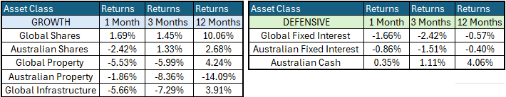
Global Share Markets
Global share markets rose in September, driven mainly by the technology-heavy United States and Japan. Narrow AI-related stock returns drove the rally, with the semiconductor index up 5% over the month, while higher oil and energy prices and rising bond yields pressured many non-technology sectors.
The U.S.-Iran conflict remained unresolved, with the seven-month war oscillating between military flare-ups and diplomatic efforts that yielded little tangible progress. Brent crude jumped more than 10% on the month and briefly rose above $100 per barrel. Elevated energy prices, particularly diesel and other fuels, reinforced inflation concerns, contributed to rising global bond yields, and posed an additional challenge for energy-importing economies.

Europe and the United Kingdom were weaker over the last month because they have lower weightings in AI-related stocks. France led the wider Eurozone lower due to continued resident rerest and higher government spending keeping inflation high, which pushed bond yields up from 4.2% to 4.9% over the month.
Australia was also a laggard throughout the month, driven by iron ore finishing below US$95/t, copper falling 4%, and gold falling on higher bond yields, with the wider materials sector down 6% for the month. The fourth interest rate hike this year also weighed on Australian equities, with expectations of another raise later this year.
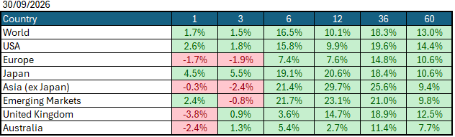
Data Source: AFM as of September 30, 2026.

Global Bond Markets
Global bond markets weakened in September 2026, delivering a third consecutive month of rising yields as investors priced in persistent inflation and a higher-for-longer policy stance from major central banks. Sovereign yields rose across nearly all developed markets, with the US, ECB and Japan leading the move, while emerging markets offset some of the weakness.
Interest rates were slightly higher in September, with the US 10-year Government bond rate rising to 5.22% and the UK 10-year Gilt rising to 5.57%
Domestic Bond Markets
Australian bond markets weakened through September as yields drifted higher across the curve, reflecting repricing of global rates, persistent domestic inflation pressures, and a clearly hawkish tone from the Reserve Bank of Australia. During the month, the RBA raised interest rates by 0.25% to 4.5%, with expectations that it may need another rate hike later this year if inflation does not make meaningful progress toward the 2-3% target range.

Investment Climate
The U.S. investment climate in September was mixed, with AI stocks outperforming despite increases in both bond yields and interest rates. Corporate earnings were resilient, with second-quarter earnings growth exceeding expectations, and AI-related capital investment continued to drive the economy. The broader economy remained solid, supported by healthy consumer spending and robust business investment tied to the ongoing AI build-out. Yet this strength was offset by a more fragile policy and geopolitical backdrop: inflation stayed above the Fed’s target, long-term Treasury yields climbed toward 5.5%, and Fed Chair Warsh’s hawkish remarks led to an interest rate hike in September. Overall, September felt like a month where strong AI earnings had to offset weakness from higher interest rates.
Over the medium term, investors are encouraged by the anticipated productivity benefits from AI and the hyperscalers' investments in AI. However, the unsettled nature of the bond markets due to the war in Iran has put the handbrake on short-term encouragement. If the US continues to raise interest rates under its new Chairman, Kevin Walsh, the medium-term outlook becomes much less encouraging.
Long-term investors are cautiously optimistic about a recovery after the US war with Iran, with energy prices expected to fall over the next year. Global central banks continue to signal their resolve to bring inflation under control, with the US raising interest rates this month after economic data showed signs of stabilisation despite elevated inflation, which could prompt further rate hikes later this year and into next year.
The following commentary is based on month-end closing prices as of September 30, 2026:
Global share markets were mixed in September, with gains in the US and Japan offsetting weakness in emerging markets, Europe and Australia, where concerns about higher energy prices and higher interest rates drove markets lower. Investors are unsure whether geopolitical events in the Middle East will end soon, with oil rising substantially over the month, reviving fears that inflation will not subside in the near term. The AUD/USD gained after US and Australian interest rate expectations shifted from 0.7167 to 0.6948 (-2.9%).
The U.S. Fed raised the federal funds rate target range to 3.75%-4.00% at its meeting on 15/16 September 2026. Last month, after bond yields rose, soft-landing rhetoric came under continued pressure amid expected inflation gains from the oil price spike's impact on food prices, bringing another US rate hike back into focus. The next Fed meeting is on the 27th/28th October 2026.
The underlying short-term theme is "mildly cautious" for shares.
The situation in the Russia/Ukraine conflict remains unchanged, with the latest conflict between Israel and Gaza (Hamas) remaining unchanged as well. Volatility and risk increased as the USA/Israel moved towards a war with Iran, with higher energy prices keeping US bond yields higher.
Investor Focus
For Australia, investors focused on the following issues:
- Cost of living expenses and the impact on consumer spending.
- Commodity prices (post-China policy changes) and the impact on company profits.
- The level of interest rates and the delicate position of the RBA, given the global volatility in markets.
- Rising Oil Prices as conflicts with Iran continue with no end in sight
- U.S. tariffs and the impact on Australia's exports (if any).
- Inflation (year-over-year) increased to 3.9% in the June quarter, with the next quarterly CPI being released on October 28, 2026.
- Government spending and the rising debt level.
- AI and its impact on both higher corporate profits and higher unemployment.
Currency
The Australian Dollar closed weaker, with AUD/USD at 0.6948 at the end of September 2026, down from 0.7167 in August. As a 'risk currency', the Aussie dollar tends to sell off during global crises, as we saw in March, regardless of local conditions. The Aussie dollar was weaker against the USD and other major currencies in September, following a global shift in interest rate expectations. 2026 calendar year to date, the Australian Dollar is also up against all other major currencies.
Currency forecasters see the AUD/USD range between:
0.65 and 0.75 cents in the medium term and most likely to trade within the:
0.5500 to 0.7500 range in the longer term.

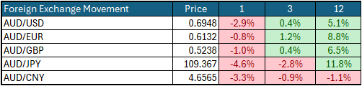

Australian Economy
Australia's latest GDP data for the second quarter of 2026 showed annual growth of 2.1%, down slightly from 2.5% in the first quarter of 2026. Unemployment rose to 4.6% in August, up from 4.5% in July 2026. The year-over-year (Y-O-Y) inflation rate rose to 3.9% from 3.5% in July 2026, remains outside the Reserve Bank's targeted 2% to 3% inflation range, and could still prompt another rate hike later this year.
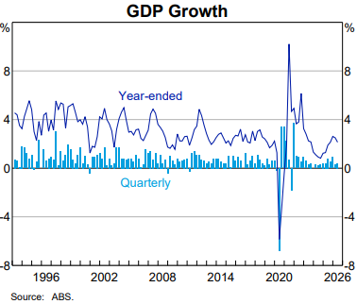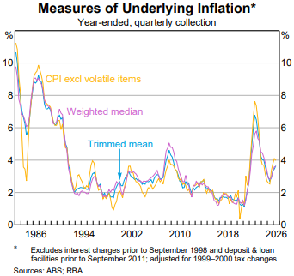

Current Market View

Domestic View
The overall investment view for shares is "cautious" over the short term, "cautiously optimistic" over the medium term, and "long run" as corporate profits continue to grow faster than inflation and as the need to build out data centres drives commodity prices higher.
The market is currently pricing in half an interest rate hike on the 2nd/3rd of November 2026, after a "hotter" August inflation print showed inflation is still outside the RBA's 2-3% target band but has begun to stop trending back down towards it.

Global View
The global share market remains cautious, with concerns around AI profitability weighing on AI companies over the month, alongside the looming threat of a global inflation spike that could force many economies to raise interest rates. Given the current tensions in the Middle East, we could see a global slowdown in GDP growth, as energy production cannot keep pace with the rollout of AI data centres.
Where to From Here
- Continued shift from rules-based order and win-win multilateral trade to power-based order and win-lose trade deals. Trump did not start this. The shift started in the 2010s with the U.S./Europe letting Putin take Crimea in return for cheap gas for Germany/Europe, and the U.S./Japan letting China militarise the South China Sea. It has certainly accelerated under Trump. Lower cross-border trade & investment, more reliance on government subsidies & distortions, and inflationary onshoring of uneconomic industries.
- Sticky inflation - political pressure on central banks to keep rates low – populist pressure on governments to keep deficit spending. Tariffs + onshoring are adding to costs/prices. Bond yields may stay elevated or even drift higher, with risk of yield spikes or a sudden need for rate hikes, unsettling/breaking share markets.
- Share markets continue to be supported by good profit growth for now. Shares are expensive everywhere, buoyed by loose monetary & fiscal policies and the near-certainty that governments will throw 'free'/borrowed money at any problem.
- Commodities rally gathering pace, rising demand soaking up oversupply, AI/data centre boom (industrial metals, energy, water, land), global rearmament, especially Europe, Japan, Canada. This should support the ASX market, as long as banks avoid a local recession.

Footnote
This market update is written by Atlas Funds Management Pty Ltd for and on behalf of HNW Planning on 15 October 2026. Atlas Funds Management is an external asset consultant and consults to the HNW Investment Committee. Atlas Funds Management does not provide any general advice or personal advice regarding any potential investment in any financial products within the meaning of section 766B of the Corporations Act. No consideration has been made of any specific person's investment objectives, financial situation or needs. The provision of this presentation is not and should not be considered as a recommendation in relation to an investment in any entity or that an investment in any entity is a suitable investment for any specific person. Recipients should make their own enquiries and evaluations they consider appropriate to determine the suitability of any investment (including their investment objectives, financial situation, and particular needs) and should seek all necessary financial, legal, tax and investment advice. Atlas Funds Management Pty Ltd, it's directors and employees do not accept any liability for the results of any actions taken or not taken on the basis of information in this presentation, or for any negligent misstatements, errors or omissions. This presentation is not an advertisement and is not intended for public use or distribution. Past performance of a fund is no guarantee of its future performance.

